Brianna Dowd
Candidate Number: 2073
Word Count: 7661

Global Perspectives Journal:

Key:
- Appropriate and challenging research question developed thoughtfully and independently by constructive dialogue, responding fully to feedback.
- Strong and consistent understanding of appropriate research methods. Methodology is carefully and thoughtfully considered and shows an innovative approach. The work is independently managed without over- reliance on teacher support.
- Highly effective and clear maintenance and use of a research log showing full support of the research process.
- Reflection on the scope, nature and limitations of the research is clear and cogent. Reflection shows a thoughtful and mature approach to how and why personal viewpoints may have altered during the research process.

August 22, 2016:
Today I met with my instructor for the first time and she introduced the course to me. She provided me with the syllabus of A-Level Global Perspectives and we discussed the initial steps to starting my research. She told me to work on formulating two questions that I believe are interesting, important to me, and something that I feel passionately about. After forming and researching both of these questions, I will meet with my instructor to decide between the two of us which question I should choose as my final research topic. Additionally, my instructor gave me a checklist of exercises that will help remind me of how to validate, analyze, and evaluate research information. Among these exercises is assisting students who are taking AS Level Global Perspectives with validations, citations, and other skills needed for papers one, two and three. Assisting AS Global Students will be a task that I will complete every week day along with my own studies. This will help me to remain adept in the skills that I will need to write paper four while I am researching.

August 24, 2016:
I started thinking of issues that I feel passionately about to research. In AS Global Perspectives, I favored medical related issues because I have an infatuation for medical research and plan to study medicine in the near future. With this in mind, I began researching topics related to medical research. I found the Johns Hopkins Medicine Research page useful, however, none of the topics listed jumped out at me immediately. I then decided to read a few recent news articles on medically acclaimed research. I was browsing through the news articles and came across one on black market organ harvesting. I had heard of this before, but never became interested enough to read further than a title or so. Turns out, I most certainly should have read further in the past because this topic is unbelievably intriguing. After reading several more articles on organ harvesting, including “Body Snatchers: Organ Harvesting for Profit” and “The Ends of the Body: Commodity Fetishism and the Global Traffic in Organs” I was captivated. There are unlimited ways to view this problem as it arises in many different manners. The problem ranges from doctors who are illegally taking and selling organs from their patients to people in LDC’s kidnapping and stealing organs from citizens on the street.

August 25 & 26, 2016:
Today I assisted students studying AS Level Global Perspectives on APA Citations to freshen up my personal skills on such. This will help me because I haven’t reviewed APA since the last semester of school and because I will need this skill for paper four, it is vital that I allow myself to review and practice this skill before writing. Along with helping the AS Global students, I also continued researching organ harvesting. My instructor met with a group of us A-Level Global students to reiterate the tasks we should be completing and to go over any questions/confusions. She suggested we find several books to read to supplement our research. I am now looking to find different books about the issue of black market organ harvesting. Moreover, I am reading about other medical-related issues to research in search of a second question.

August 29, 2016:
Today while watching the news, I heard a story on CNN that there is currently a strong demand on the U.S. black market for kidney donors. Several people admitted to the news agency, and thus the world, that they are selling or previously sold one of their kidneys solely because they need or want the money. They earn this money by selling a part of their body, which, to me, seemed eccentric because in no way would I ever imagine donating an organ for the satisfaction of getting paid. This opened a whole new door to research for me because I now am thinking of this issue in an economical perspective. Not only is this an issue of ethics and medical ability, but is expanded to economics due to the massive revenue it can bring a donor or a stealer. Beyond this research, I reread my paper two from AS Global Perspectives to remind myself of the research process and to reflect on what sources I thought were good and which I thought could have been better.

August 30, 2016:
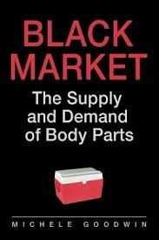
I continued assisting AS Global students on fallacies which will help me when reading articles to distinguish between reliable and unreliable sources. I also researched and attempted to narrow down books that I plan on reading for my first topic. I found Black Markets: The Supply and Demand of Body Parts a potential read due to its relevancy to my topic and interesting title. As it seems that this book will address different aspects of the issue, I believe it will be a great place to start, however I may need a more specific book further in my research. I additionally started formulating a question that involves the black market organ harvesting. I am currently working with “Should organ harvesting take place on the black market?” Although this question would work for what I plan on doing at the time, I don’t particularly like it and will tinker with the structure and wording as I go along.
(Black Market The Supply and Demand of Body Parts, 2016)

August 31, 2016:
I decided that in my first topic question, I want to include the word “trafficking” when addressing the black market of organ harvesting because I feel that the definition of this word, as defined by the Cambridge English Dictionary as “the activity of buying and selling goods or people illegally”, thoroughly represents the process of organ harvesting on the black market. I believe the use of this term in my question will clarify the research topic and increase the accuracy of the question. Today with AS Global students, I assisted in teaching and formulating validations for electronic sources. This forced me to review my personal validations that I used previously and to start thinking in terms of evaluation of sources. This task will surely help me to further my evaluation skills while validating sources for my own research. My instructor checked in on my logs to ensure that I am keeping up with them and reminded me of the tasks I need to be completing, such as formulating my two questions, finding books on those topics, and practicing skills needed for paper four.

September 1 & 2, 2016:
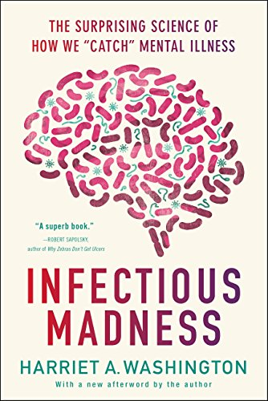
I went to the library to look for inspiration for a second topic to formulate my second question. While browsing the non-fiction science section, I came across a book that caught my eye. It was titled Infectious Madness. The book’s category could be considered psychology but it is specifically about the science of “catching” a mental illness from germs present in our everyday lives. After reading the synopsis of the book, I was left wanting to know more about how people could “catch” a mental illness and whether this was common and where. I began researching this further online and discovered that “catching” a mental illness is an actual threat to people all over the world. Additionally, during this time, I helped AS Global students with forming questions. This skill is something I needed to refresh myself of considering I haven’t used this skill since the last semester of school. Helping the AS students will moreover help me to better construct my two questions needed for my course.
(Infectious Madness, 2016)

September 5, 2016:
Today I did not have school due to the national holiday, Labor Day. In spite of this, I took advantage of the day to continue my research. I decided to formulate my two research questions as my topics are already solidified. This will help me to stay on schedule considering my instructor wants my proposal submitted to her by October 20. For my first topic regarding organ trafficking, I believe a question such as “Organ trafficking: saving lives or ruining them?” would be most intriguing and best fitting. For my second topic regarding germs and the ability to catch a mental illness, I believe a question such as “Can you catch mental illness?” would be best fit for the topic area. Although these questions may change throughout my research progress, I feel as of this moment, these are the best fit questions to allow me to move on in my research.

September 6, 2016:
I met with my instructor as well as some other A Level global students and we discussed the tasks needed to be completed before she allows us to meet with her over which question our research will form from. Of these tasks is completing a literature review or research review on both topics that we choose to research. My instructor offered us her personal literature review on her doctoral dissertation to use as an example for our own literature review. A literature review will help me to organize my research as well as solidify a direction that I want my essay to go in before deciding which topic will be better fit for my final research essay. Along with a literature review, my instructor is requiring us to have found two authors for each topic of research who have concrete judgement or insight on the chosen topics. As I have already found two authors, I am well on my way to completing these tasks in order to have my meeting with my instructor.

September 7 & 8, 2016:
I went to a library in search of books to begin to develop a concrete background on my two research topics. I found through research that Gulf Gate Library had a large selection on mental illness books so I went there and found two books on mental illness in their inventory. The books take contrasting views on what causes psychiatric disorders. The first book is the work I mentioned previously, Infectious Madness, and argues mental illness is caused by germs in our environment. The second book is titled Anatomy of an Epidemic, and argues mental illness is caused by biological occurrences and inheritance. These books, I believe, will enable me to see mental illness from different viewpoints which will solidify my background knowledge on psychiatric disorders. Additionally, I started reading papers from past A Level Global Students who received high scores to take note of different styles and methodology for writing this paper.

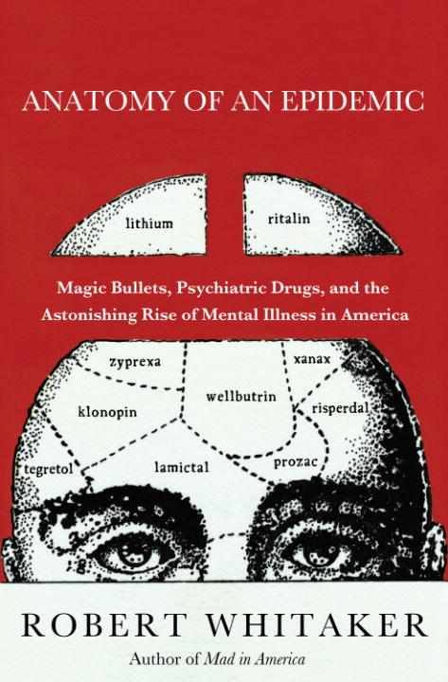
(Infectious Madness, 2016) (Anatomy of an Epidemic, 2016)

September 9, 2016:
Today I went to a different library, Fruitville Library, in search of books on organ trafficking. I found two books on the subject which give different perspectives on the black market of organ trafficking. The first book is titled The Red Market which is an account of a world renowned journalist’s journey through the multibillion dollar underground trade of human body parts. The second is titled The Slaughter, and goes into the organ trafficking market in China where people kill others in order to sell their organs. These books will broaden my perspective on the issue as well as provide me with the background knowledge I need to move forward in my research. Along with my library visit, I also assisted AS Global students by proofreading their deconstruction assignment for their course. This reminded me of the components I need to look for while deconstructing books or articles that I read. I believe this task will especially help me when I begin reading my books so that I can break down what I am reading to fully use the work to its potential.
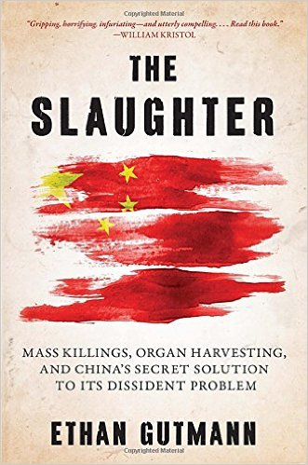
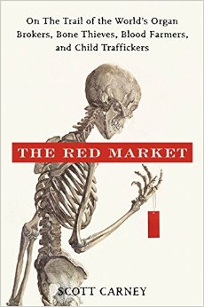
(The Red Market, 2016) (The Slaughter, 2016)

September 12, 2016:
I met with another A Level Global Perspectives student whom I will frequently work with when peer reviewing, planning, or encouraging in the research process. For the purposes of this log I will call her Sierra. Sierra and I discussed our topics and advised each other on the wordings of our questions. We also agreed that we should start planning out our research in a concept map form to keep organized while working through the process. She appreciated the questions I have currently but confirmed that they may change depending on where my research takes me. I also continued helping AS Global students in learning the basic skills needed to be successful in the course, such as deconstruction, setting up reference pages, and crafting validation statements. Helping other students learn these skills will ultimately make my skill set stronger in these areas which will help me once I begin writing my paper.

September 13, 2016:
Today I began reading the books that I checked out at the library. Due to the fact that I will be reading multiple books at once in order to maintain time management, I decided to keep a running list of notes for each of the books I will read. These lists will be comprised of facts that I want to remember, things I believe are interesting, notes for direction of my essay, and anything else pertaining to my research that I believe will help me. These lists will then be used to plan my research and construct my scaffolding once the time comes. Additionally, I helped AS Global students with writing/editing their first essay. This reminded me of the methods I found useful while writing my own essays and will surely help me when moving forward and writing my A Level essay.

September 14, 2016:
I researched how to write a literature review today and I found a website that gives the basics of how to write it. This is a skill that I don’t have much experience with so I feel that I should familiarize myself with the task as much as possible. I believe I now have a basic understanding of what a literature review is. On top of this, I read the literature reviews of students in my school who took and scored highly on A Level Global Perspectives last school year. This especially helped me because I obtained a visual of approximately how long my personal review should be and I got an idea of the components that need to be in the review. I also continued to read the books that I checked out from the library.

September 15 & 16, 2016:
Today I started researching the topic organ trafficking on the internet. I wanted to browse the different articles that came up when I searched the overall topic. I found that many articles talked out China and Indonesia, common places of organ trafficking. I also found that like human trafficking, organ trafficking attracts organ transplant tourism. Furthermore, I found an article on who it is that is harvesting these organs to sell. One interesting fact, according to Philip Perry, is that the UN is currently looking into reports that ISIS may be selling its victims organs to fund their terrorist activities. These research findings are helping me to build a broader sense of knowledge on the topic of organ trafficking so that I can begin collecting literature for my literature review.

September 19, 2016:
Today I discussed with my instructor my topic of organ trafficking. I felt shocked but excited after finding out more on how doctors in America were being linked to ordering organs from ISIS victims. I felt the urge to talk to someone about this problem and turned to my instructor, Dr. Crihfield, who I knew would share my excitement. We discussed this subject and some other A-Level students joined in on the conversation. Afterwards, my instructor unofficially told me that I had found my final research topic. She explained this in a way that truly made me think. She said “…well it seems like you didn’t pick your issue, but instead your issue picked you”. The more I thought about this, the more sense it made. I truly didn’t pick this issue, but rather stumbled upon one single person’s case of organ trafficking and was impacted so heavily that I had to know more. This issue, although if you asked me a year ago I would be largely unaware, is now something that I feel passionately about and genuinely curious of. I look forward to finding out more in the near future.

September 20, 2016:
I obtained a copy of the A-Level global perspectives syllabus today and read through it thoroughly. I made notes of questions that I plan on asking my instructor once she returns from her AICE training on advanced global perspectives. I look forward to moving on in my research process by confirming what I need to be doing according to the syllabus. I also look forward to hearing what my instructor learned at this training that pertains to A-Level global perspectives.

September 21, 2016:
Today I started an annotated bibliography of sources that I find interesting or helpful for my research on organ trafficking. I also started organizing some of the research that I found previously that helped me build my question. This annotated bibliography will help me to keep organized of my sources while I progress so that I can remember what each source was without having to re-read it. Organizing my research will help me move forward and start building reasons for my argument as I review literature on the subject.

September 23, 2016:
Over the next couple of days, I will be preparing for my meeting with my instructor to decide my final research topic. The preparation for this will be a good amount of research in order to solidify my background on the two subjects. I will also prepare a small scaffolding for both topics in order to establish that there really are two sides to the questions and that there is enough research on the subject. This available information and past research is vital to complete a literary review and to base a research essay of off.

September 27, 2016:
I scheduled a private meeting with my instructor today to discuss my two topics in full and decide which of the two would be best fit for researching. We decided that my official topic will be human organ trafficking. However, she told me that I could use the other topic to practice writing portions of the essay that she would be able to give me feedback on. Although I decided my official topic in this meeting, I realized my journey was far from over. We discussed at length the different aspects of organ trafficking. In this discussion, I realized that my question was far too broad than I wanted it to be. I was suggested to make a concept map of my original question and all branching questions in order to organize my thoughts and formulate what route I wanted to go.

September 28 & 29, 2016:
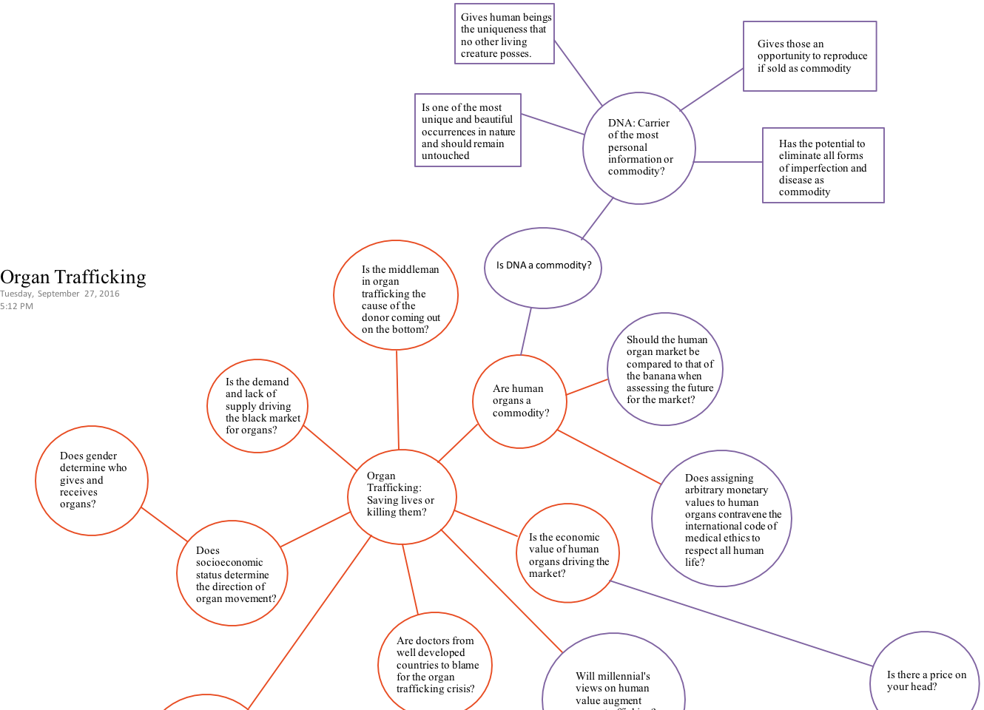
I continued creating my concept map as ideas came to me. I discussed with many friends and fellow students the subject of organ trafficking and received outside knowledge and opinions on the subject. This helped me to determine what aspects of organ trafficking people didn’t know about, or found interesting. It also helped me create additional questions. After some time, I ended with this:

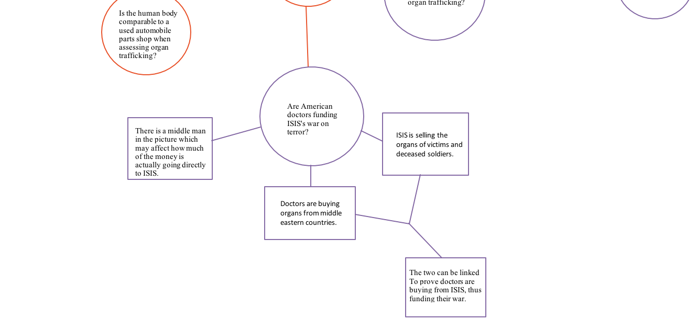

October 3, 2016:
Of these sub-topic questions, I was leaning most towards “Are American doctors funding ISIS’s war on terror?” This question was most interesting to me and I felt strongly connected to it as one day I hope to be an American doctor; however, I was disgusted by the fact that they were linked to buying organs from ISIS. After further discussion with my instructor, I realized that I needed to make this question broader, seeing as there wasn’t much data on the specific subject. I know that I want to create a clever question that addresses who is to blame for the organ trafficking crisis. Over the next couple days, I will be brainstorming questions for this.

October 6, 2016:
Over the past couple of days, I have been playing around with different questions. Ultimately, I decided that the question about American doctors and ISIS was too specific and too recent to be able to find a good background of information on. I started thinking about the broad scheme of organ trafficking and I realized that the people involved in the trafficking can be put into categories of the buyer, the doctor, the receiver, and the middleman. I realized that I wanted to write my essay on essentially who is most to blame for black market organ trafficking. I just had to figure out how to put this into a question. I decided to talk to my instructor to hear her input on my dilemma. She told me it reminded her of the children’s rhyme “Rich man, poor man, beggar man, thief…” This immediately stood out to me because this rhyme is the children’s way of choosing a person which can be symbolically related back to how I am researching who is the most to blame for organ trafficking. Thus, I decided my question would be “Organ Trafficking: Rich man, poor man, beggar man, thief?”

October 10-14, 2016:
During this week, I worked on my proposal. I wrote a draft proposal containing the following: why I wanted to research this topic, how I was going to organize my research, what I had learned so far, and how it affected me. I revised my draft and gave it to three other A-Level Global students to review. I made a few changes after reading these reviews and repeated the process several more times until I felt truly satisfied with my final copy. I submitted this proposal to my instructor to be sent to Cambridge. While I did this, I was also using the time to continue researching lightly. Although I know I have to wait on my proposal’s approval to fully continue, I decided that it wouldn’t hurt to continue to read about my topic and organize my thoughts and ideas. I continued reading articles and journals on black market organ trafficking.

October 17-21, 2016:
Over the course of this week I have awaited on the return of my proposal. During this, I continued keeping updated on my topic and reading several books on the subject. I also have taken the time to research the second topic that is aforementioned. I will use this topic to write a small section of the research essay so that my instructor can give me feedback on how I am doing with the skills needed to earn high marks on this exam. Alongside this, I have been grading scaffoldings and other AS assignments in order to keep my skills sharp. As it is said, if you can teach something it means you truly know it yourself. Thus, grading the AS student’s papers greatly helps me to make sure I am doing all the skills I need for paper 4 correctly.

October 26, 2016:
I received my grader’s comments on my proposal and found out it was not approved. At first this was a huge disappointment for me. I had high hopes in my proposal and was puzzled as to why it wasn’t approved. After reading the comments many times, I beyond agree with the grader. Some of the comments were that the title was not in the form of a question and that the report should take the form of a debate. I am grateful that the grader gave me these comments because I feel that how I currently had my report planned out would not have worked. It is extremely helpful that the commenter also told me the research report was comparable to a debate. This helped me to realize that I needed to establish two clear perspectives on the issue.

October 27 – November 1, 2016:
Over this time, I worked on writing a new proposal to re-submit. I decided to keep the same issue of organ trafficking because I feel passionately about this issue and I believe this will lead itself to a deep analyzation of the problem. I remade my question and ultimately decided on “Is organ trade an ethical solution to resolving organ shortages?” This question is much more debatable and allows me to clearly argue from two different perspectives. This question changed my research in that I will be focusing on whether organ trade, or the selling of human body parts, is ethical. I’ve considerably narrowed my research with this question but clearly defined what I will focus on. This will help me to remain focused on the issue when conducting a literature review or writing the research report. In this proposal, I’ve defined what two sides of this I will be arguing by saying, “Some individuals believe that organ trade is acceptable and ethical because it provides incentive for people to donate organs which could save someone’s life. In a time of severe shortages of organs being donated, it is a large medical concern that organs are donated. Nonetheless, others believe that organ trade is immoral and unethical for many reasons, including it goes against religious beliefs and it assigns an arbitrary value on the human body.” I sent this proposal for regrading.

November 3, 2016:
I received my comments from my re-submission of the proposal. My proposal was approved with proviso. My grader approved with the proviso that I can present a debate between two distinct overall perspectives and support each with arguments and reliable evidence. My grader also suggested that I reword my question to either “Is the organ trade an ethical solution to transplant organ shortages?” or “Is organ trading an ethical solution to transplant organ shortages?”. I will be using “Is organ trading an ethical solution to transplant organ shortages?”. I plan on reading the comments and following them very closely throughout the remaining process of my research. Within the next couple of weeks, I will be gathering reliable evidence that supports both sides of this issue.

November 7-11, 2016:
Over the course of this week I have spent my time reflecting on the graders comments as well as helping AS Global students in order to prepare myself to begin writing my own report. Thinking back on the proposal process, I’ve realized that I learned a lot. I learned that my research must take the form of a debate and have two overall perspectives. I also learned that it is sad, yet extremely helpful to be told no. What I mean by this is that I realized that my research report would not have been as successful if I wasn’t not approved and given the chance to think about what the report requires and how I should be setting it up. With my original question, I was trying to take on too much in a 5000-word report. There would have been no way I could do it. The grader’s comments ultimately helped me to narrow my research and realize what the requirements of the report is. So I greatly thank the grader. Additionally, I’ve been helping the AS students with learning how to analyze. I am doing this with the help of some other A-Level Global students by putting together a lesson on analyzing. This will greatly help me to become better at analyzing myself and will help me when writing my research report.

November 14, 2016:
This week I will be working on writing part of a sample paper for my instructor and peers to grade. I will be writing on my alternative topic of mental illness so that I can give this to my instructor and so that she can help me determine the skills I need to improve on.

November 16-18, 2016:
For the demonstration of my analysis and evaluation skills I found an article published by the Research Institute for Infectious Mental Illness on how the Herpes infection can cause mental illness in unborn infants. This practice helped me to refresh my skills of searching for credible quotes to support my thesis, a skill that I needed to refresh on. With this example from the research institute, I analyzed the content and I analyzed the source. Using both of these, I made an overall evaluation of the quote according to the thesis. This practice exceedingly helped me to refresh my analysis and evaluation skills, which are vital in paper 4. My instructor got the comments back to me quickly and confirmed that I did the exercise correctly and that my skills are up to par.

November 21 & 22, 2016:
My instructor asked me to instruct a lesson on analyzing for the AS level global students. I had the task of preparing and carrying out a lesson so that the students could better understand the skill of analyzing. This task would also help me to deepen my understanding of analysis. Thus, over the course of the weekend and some of the week I prepared a lesson on analyzing using a tool that I knew the students would understand: social media. I had them analyze social media posts according to the thesis “Should I quit social media?”. I felt that this method worked well in teaching the students how to analyze. They understood the social media posts and realized that in analyzing, they didn’t need to summarize the post but simply explain how the post effected the thesis and why it was important in proving the thesis. After the activity, I feel much better about being able to analyze excerpts or quotes for my own research report considering I was able to grade and comment on each student’s analysis that they turned in to me. I additionally feel that my understanding between analysis and evaluation has deepened.

November 23-25, 2016:
During this time, I did not have class due to the American Holiday Thanksgiving. In spite of this, I took advantage of the break in order to start scaffolding the ethics of organ trading. I began planning out the different reasons to support my thesis/concession. I additionally continued researching quotes and excerpts to support both sides of the issue. I am keeping a running annotated bibliography so that I can easily see which sources I have used or need to use. This bibliography will be useful for when I go to write my literature review. I especially took advantage of the break to organize my thoughts and research. I updated my notebook that my instructor is having us keep and I organized my research into the beginning of my scaffolding. This will prepare me for a fresh start this coming week to work to finish my scaffolding due on the 15th of December.

November 28-30, 2016:
I started officially formulating my literature review. I reexamined the different aspects of the debate of which I will tackle and I made note of the categories that must be discussed in order to give a relevant review of literature for my research. The following are the sub-titles I came up with for my review:
- Overview
- Ethicality
- Legality
- Religious Standpoints
- Medical Standpoints
- Influence of Western World
These titles will give me the ability to wholly review the research already done by leading specialists in this topic area. I also confirmed and reworded the reasons I wrote previously and began searching for/gathering evidence to support those reasons.

December 5-7, 2016:
Over these days I reviewed sources from my annotated bibliography and gatherings from my desk research in order to plan out sources for my scaffolding. I went through my compiling of sources and categorized which support the different reasons for my thesis and counter-thesis and sorted them accordingly. After this, I removed the sources that I didn’t feel best supported my reasons. With what was remaining, I put into the scaffolding. When necessary, I researched more material to support my reasons. This use of desk research best fits my area of discussion because there is a sufficient amount of data readily available on the topic of organ trade, so much that it is unnecessary for me to do primary research. After assigning sources as evidence, I began the task of validating the authors of those sources and evaluating the evidence against the thesis.

December 8 & 9, 2016:
I continued working on my scaffolding. The final product of the scaffolding will make the essay writing more organized and allow my peers to easily critique my writing before putting the work into essay format. The scaffolding is to include everything that the essay will except transitional phrases. Thus, it is important to work on this as much time as I can in order to ensure that it is up to my standards. While working on this, I’ve been reviewing evaluation in other essays and methodology to guarantee that I receive as many marks as possible on evaluation, a particularly challenging skill in my opinion.

December 12-14, 2016:
As I continued research, I realized there was an alternative perspective to the counter-thesis that I had not thought of previously. I recognized that organ trading could actually reduce societal health care costs. Economists from the University of Chicago found that by comparing the costs of paying a living donor to trade their organs to the costs of remaining on dialysis (the alternative to receiving a transplant). Dialysis is typically covered by health care, and because dialysis is extremely expensive, replacing it with a system where a donor would be payed to donate would reduce societal health care costs. Findings as such open further discussion to the ethicality of organ trade.

December 15 & 16, 2016:
During research, I additionally found leading author on such issues, Kate Greasley, wrote extensively on how the monetary value of organs creates a vulnerability to exploitation of the poor. This is a serious concern that deserves much attention when dealing with the ethicality of organ trade. One of the biggest concerns of this method is the fact that it would exploit the poor, who are in most need of money. It is an immense advantage to my research to find authors such as Greasley.

December 19, 2016-January 2, 2017:
Over this period of time, class was not in session due to the holidays. Before we left for break, a group of A Level students submitted our scaffoldings to our instructor for her to distribute them to us so that we could review each other’s before writing the final draft of the essay. Our instructor agreed to send the scaffoldings to us after the break. So during this time, I took a break from my research to help me clear my mind and allow me to review my work after I come back with an open and fresh cognizance.

January 3-6, 2017:
After a period of thought and reflection, I decided to review the authors that I planned on citing for my report. I noticed one of my quotations was from the Quran. It reads, “So set your heart on the religion as a people of pure faith, the origination of Allah according to which He originated mankind; There is no altering Allah’s creation; that is the upright religion…” (Quran 30:30, Oxford World's Classics edition). Considering this is such a highly followed source and significant to many people around the world, I felt this source needed a deep validation: The quoted material comes from the Quran, described by select Muslim scholars as the Arabic speech of Allah that was revealed to the Prophet Muhammad both in word and in meaning and was collected between the two covers of the mushaaf, narrated in mutawaatir chains, and is a challenge to humankind. Nonetheless, followers of this work only account for just over a fifth of the population worldwide.

January 9-11, 2017:
During this time, I was given a copy of five other A-Level Global student’s scaffoldings to peer review and help them make any corrections necessary to increase their marks on this paper. I began to make general comments on those. This helped me exceedingly because I got to view other student’s work, some whose was better and some whose was worse than my own. This helped me gauge where I stand and how I could improve my research and report to better my score. Additionally, I had a meeting with my instructor as well as all the other A-Level students. We discussed our progress on the research and what we should be doing at this point.

January 12 & 13, 2017:
After reading other A level scaffoldings, I took time to reflect upon my own. I recognized that the lack of primary research is a limitation to my research report. Primary data, if collected and used in the right way, is more convincing than reproduced data. However, the nature of this topic lends itself to desk research because of the fact that it would be extremely difficult and not to mention dangerous for a student such as myself to collect data in least developed countries and hospitals. To compensate for this limitation, I feel my report utilizes the best sources and expertise in the field who did conduct their own research.

January 16-18, 2017:
Over this time, I continued peer reviewing other A-Level Scaffoldings. This process has helped me in ways I couldn’t have imagined. From other student’s work, I’ve realized some mistakes that others make that I didn’t know I made myself and this helped me to notice and correct that. Also, by helping others with analysis and evaluation, I have solidified my understandings of those terms and where I should be looking for it in my report. Furthermore, I had another meeting with my instructor and some other A-Level students. My instructor reviewed the syllabus with us and mentioned that we should not only be using it to make comments to our peers, but also when we are editing our own reports.

January 19 & 20, 2017:
My instructor presented me with an alternative task aside from my paper which is to teach skills necessary to successfully complete paper 1 to the AS global students. I understood this task and that it would help me better my skills in assessing the validity of an author and their arguments. I went about preparing this independently by reviewing past paper 1 exams and making notes on important things to remember when deconstructing an argument as well as how to analyze and compare the quality of their arguments and expertise. This task will especially help me not only when I am peer reviewing other’s papers but also when I am deciding whether to use an author in my own research report. Furthermore, I self-sufficiently instructed two other A level global students to help me teach these skills which would help them too in the near future.

January 23-25, 2017:
On Monday I received an email containing comments on my scaffolding from my peers. I have been spending time going through each peer’s comments and reflecting on how I need to change my essay to better it. While reading the comments, I noticed that many wrote about how I need to define or clarify certain aspects of my paper pertaining to medical terms or concepts. This reminded me that I needed to write this paper so that a non-specialized reader could understand it. In editing my paper, I plan to strongly consider explaining concepts that the average person wouldn’t understand and this will come in the form of further analysis of examples.

January 26 & 27, 2017:
Over this time, I have reviewed my work and decided I needed to reflect on where I started with this research and where I’ve come to. At the beginning of my research, I didn’t have an established opinion on organ trading and whether it is ethical. I assumed there was no problem with such a system because I thought how could a system that brings organs to people who need them be unethical. After immense research and many months of continuously reading on the subject, I realized there are various reasons as to why this isn’t ethical. The leading reason is that the system exploits the poor. Alternative reasons as to why organ trade isn’t ethical include, the system goes against religious beliefs and it results in postoperative complications. Looking at this side of this issue made me sympathetic to those who the system exploits, but at the same time I still see a system the ultimately helps people. As my aspiring career is to help people through the practice of medicine, this was an issue that I went back and forth with in my mind. Is one life worth more than another? People in less developed countries are dying to give their organs to people in developed countries. Eventually, I came to the conclusion that unless there are some serious restrictions that eliminate all forms of exploitation in this system, it cannot be ethical.

January 30 & 31, 2017:
I began editing my research report according to my peer’s comments. One comment that particularly stood out to me was that I needed to make my introduction into the topic more analytical. I re-read through this section of my report and I felt this comment was spot on. I will be spending this time making this section more analytical and with that evaluative to make sure I am reaching the maximum points where I can earn the most. I will additionally be reading through the rest of my paper to make sure the analysis and evaluation throughout is up to my standards.

February 1-3, 2017:
During this time, I reviewed my weakest example and decided to throw it out and find a better example to support my reason. I originally had a study proving that Americans would be more inclined to donate organs if they were payed to do so, but the study was a survey which doesn’t exactly prove this system would work. I instead replaced this with a study of where a system like this was put into place and it increased organ donations. This example far betters my claim that the market incentives increases the supply of transplant organs because it shows that a system like this would actually increase the supply of organs for transplantation.

February 6 & 7, 2017:
I took this time to review the Cambridge Learners guide before continuing in my editing of my report draft. I felt this was necessary at this point in my research to remind me of what specific aspects I need to work on in my essay. During this review, I realized that I needed to address my personal opinion on the subject. This is something I didn’t realize should be in my report because I thought that it was only necessary to give data and evaluate that, however, the learners guide expressed that it is beneficial for the reader to understand the author’s viewpoint. Moreover, I remembered to be sure to focus on the evaluation and analysis of my research findings in my essay.

February 8-10, 2017:
The scope of my research consists of all systems where organs are being exchanged for monetary compensation in all countries around the world. The analysis of ethicality in my research broadens the scope further considering ethicality can span a wide range of ideals. Nonetheless, as with any research, my research has limitations. One being that the use of case studies brings generalized findings that may or may not apply to all similar cases. For instance, the effects of one unit of analysis may not reflect all effects of the type. This means many of the drawing made from case studies might be slightly generalized. Another thing that is hard to avoid is the comparison of just a system of donation to a system of paid donation. It is arguably correct that some of the negatives to a system of paid donations are also negatives in a system of just donations, however, negatives are still negatives and the comparison of the two is unnecessary in my research.

February 13 & 14, 2017:
During this, I reviewed essays of peers partaking in A-Level Global. We exchanged essays for a final time to review each other’s work to ensure excellent research reports. The peer reviewing process always helps me to be thinking about things to work on in my own essay. I additionally understand the rubric and the grading process better when I have to use it to help other students with their essays. Beyond that, the process helps me because I get to see what others who have no experience in my research subject have to say about my report, which helps me in the editing process.

February 15 & 16, 2017:
I have been editing my essay according to my peer reviewer’s comments. While there were very few comments from most of my peers, I had a handful of very insightful comments given for me to work with. Ultimately I need to work on my introduction to make it more analytical, evaluative, and to apply it to my question. With my edits, my essay should be ready to submit.

February 17, 2017:
After finishing my research report, and thus my entire research process, I feel it is appropriate to write my last entry in reflection. Not only did I learn so much about research and writing that will beyond a doubt help me in college, but I also learned a significant amount about the subject of organ donation. While I do personally believe that a paid organ donation system is unethical, I clearly understand the arguments of the other side. The aspect of the issue that bothers me most is that the poor go through the system like a piece of meat in a factory with a price tag. It is absolutely unfair. A question that arose during my research that I genuinely wonder is whether there is a system that would increase the supply of transplant organs without creating exploitation or breaking norms of ethicality.

